Hiyab Mengisteab
Data Preparation Task 1

A. Profile Data

General Characteristics of the Initial Dataset:
- The dataset contains 10,199 data rows (1 headers row) and 16 unique attributes as columns. It captures detailed employment-related information, including turnover status.
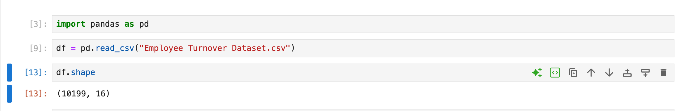

Data Type, Subtype and Sample Observations for each attribute:
Attribute | Data Type | Data Subtype | Sample of observation
EmployeeNumber | Quantitative | Discrete | Unique identifier for each employee [1, 2, 3]
Age | Quantitative | Continuous | Measured in years [28, 33, 22]
Tenure | Quantitative | Continuous | Duration of employment (in years) [6, 2, 1]
Turnover | Qualitative | Nominal | Yes/No value
HourlyRate | Quantitative | Continuous | Dollar amount, includes decimals [24.37, 22.52]
HoursWeekly | Quantitative | Discrete | Whole number hours per week [40]
CompensationType | Qualitative | Nominal | Category like "Salary"
AnnualSalary | Quantitative | Continuous | Dollar amount, includes decimals [50689.6]
DrivingCommuterDistance | Quantitative | Continuous | Distance in miles [89, 35, 12]
JobRoleArea | Qualitative | Nominal | Job department/category [Research, Sales]
Gender | Qualitative | Nominal | Includes "Female", "Prefer Not to Answer", etc.
MaritalStatus | Qualitative | Nominal | "Single", "Married", etc.
NumCompaniesPreviouslyWorked | Quantitative | Discrete | Count of companies [3, 6, 1]
AnnualProfessionalDevHrs | Quantitative | Discrete | Whole number of hours [7, 8, 19]
PaycheckMethod | Qualitative | Nominal | e.g., "Mail Check", "DirectDeposit"
TextMessageOptIn | Qualitative | Nominal | Yes/No/N/A

B. Inspect the dataset for the following data quality issues

1. Duplicates
Inspection:
Used df.duplicated().sum() to count duplicate rows.
Findings:

2. Missing Values
Inspection:
Used df.isnull().sum() to identify columns with missing values.
Findings:
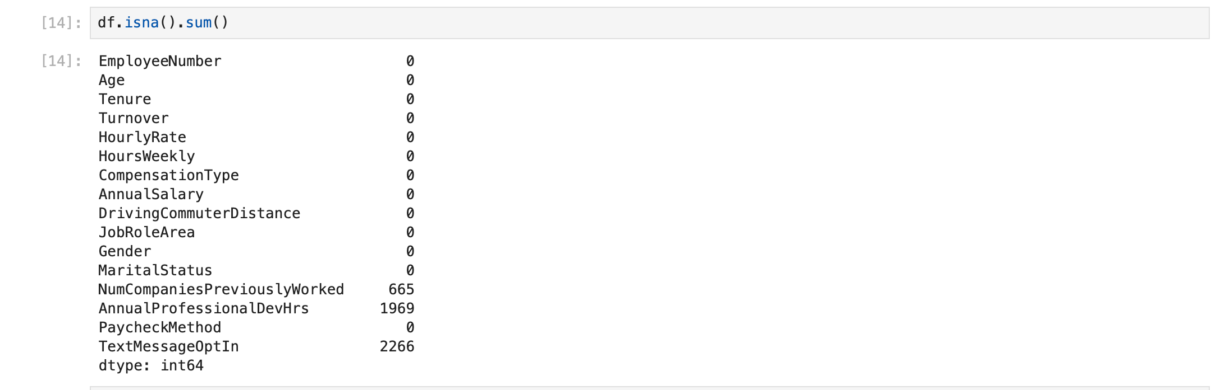

3. Outliers
Inspection:
Used scatter plots to check for numeric outliers in int64 column: Hoursweekly
Findings:
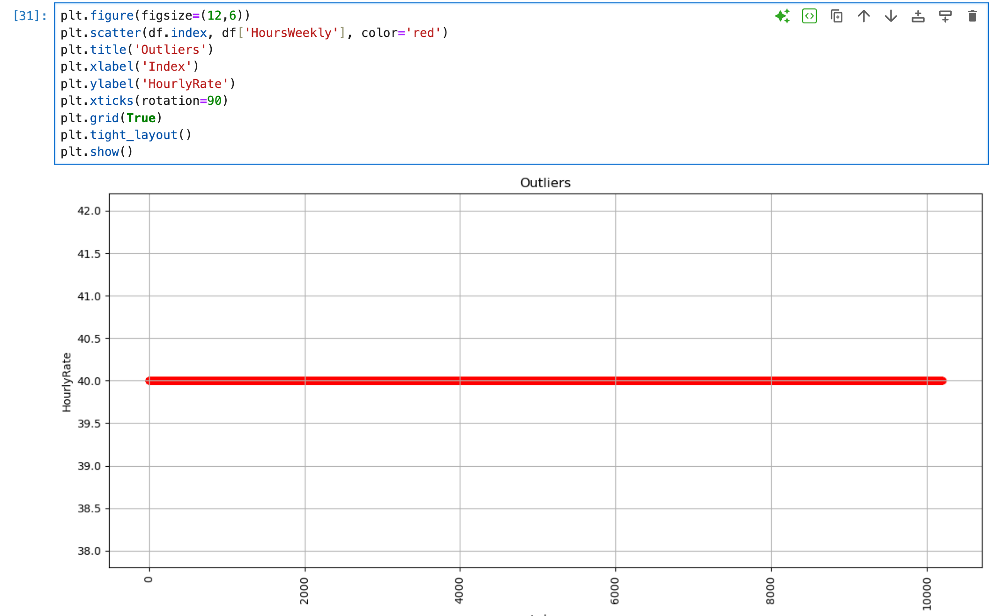

4. Standardizing Formats
Inspection:
- Checked for data type using print(df.dtypes).
- Checked for unique values for each column.
Findings:
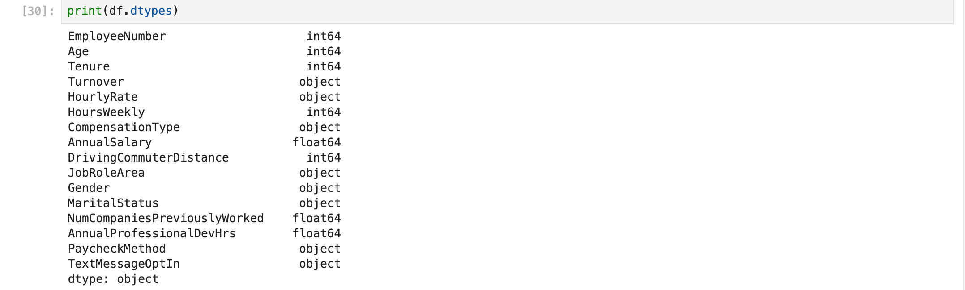

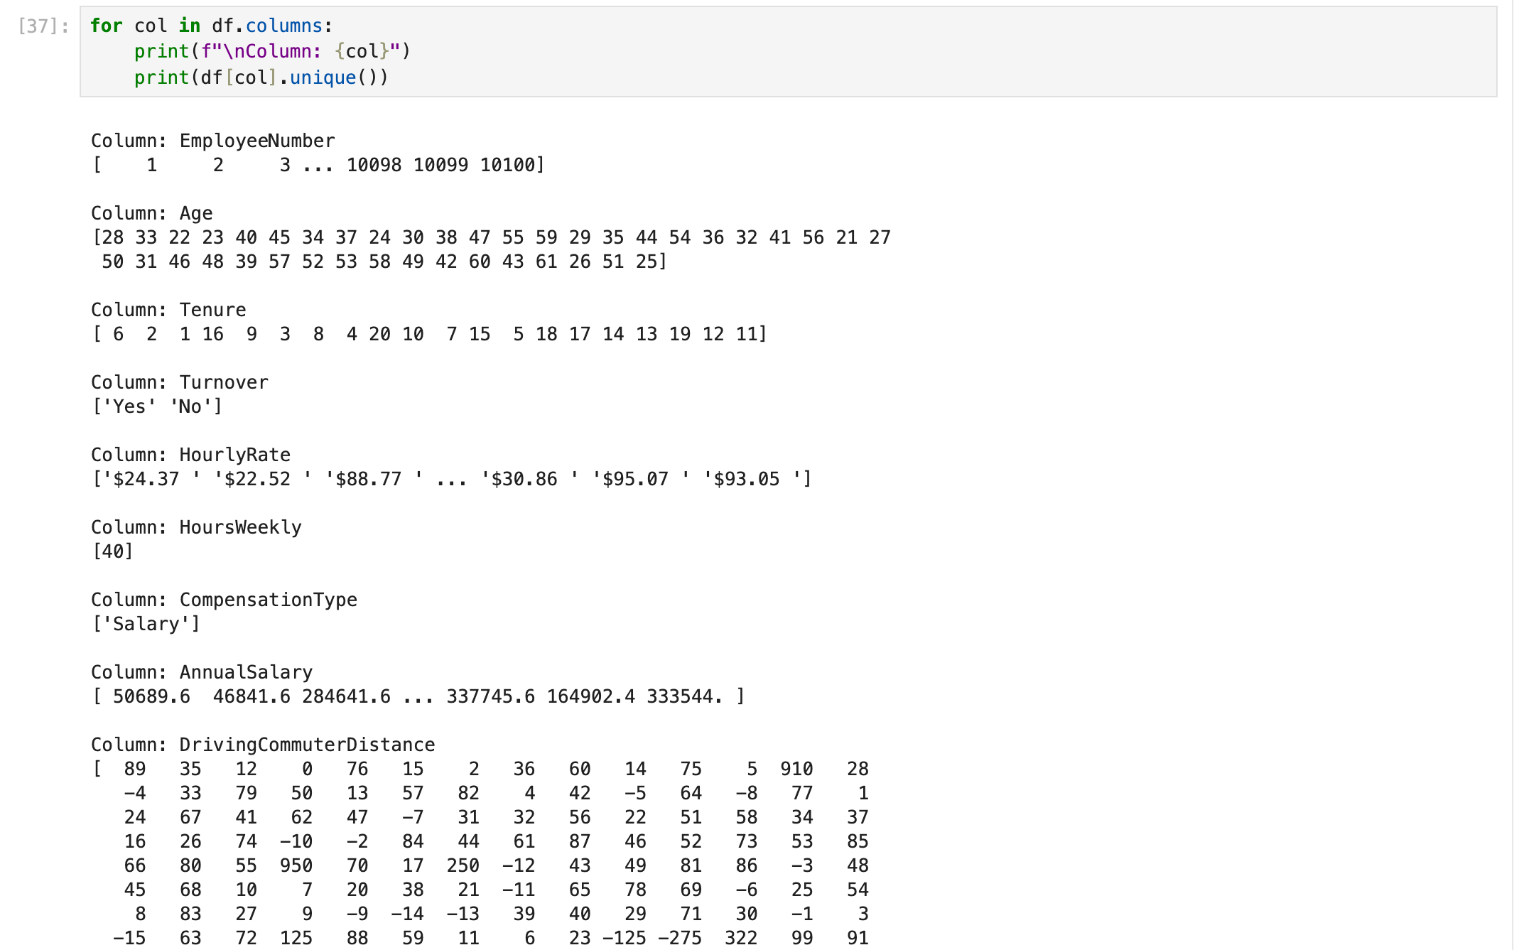
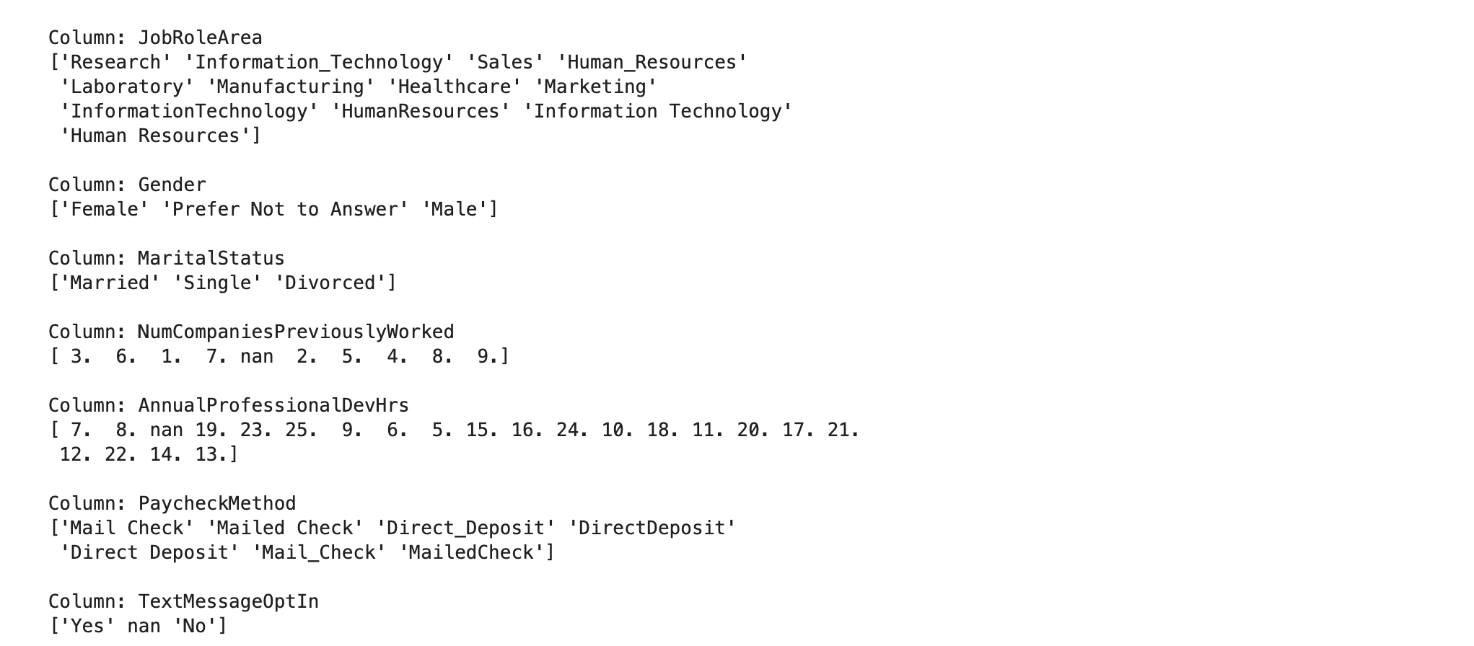
- Colomn Paycheckmethod is containing different formats to input Mailed Check or Direct Deposit values

5. Data Accuracy
Inspection:
- Used unique values to identify data accuracy
- Display value

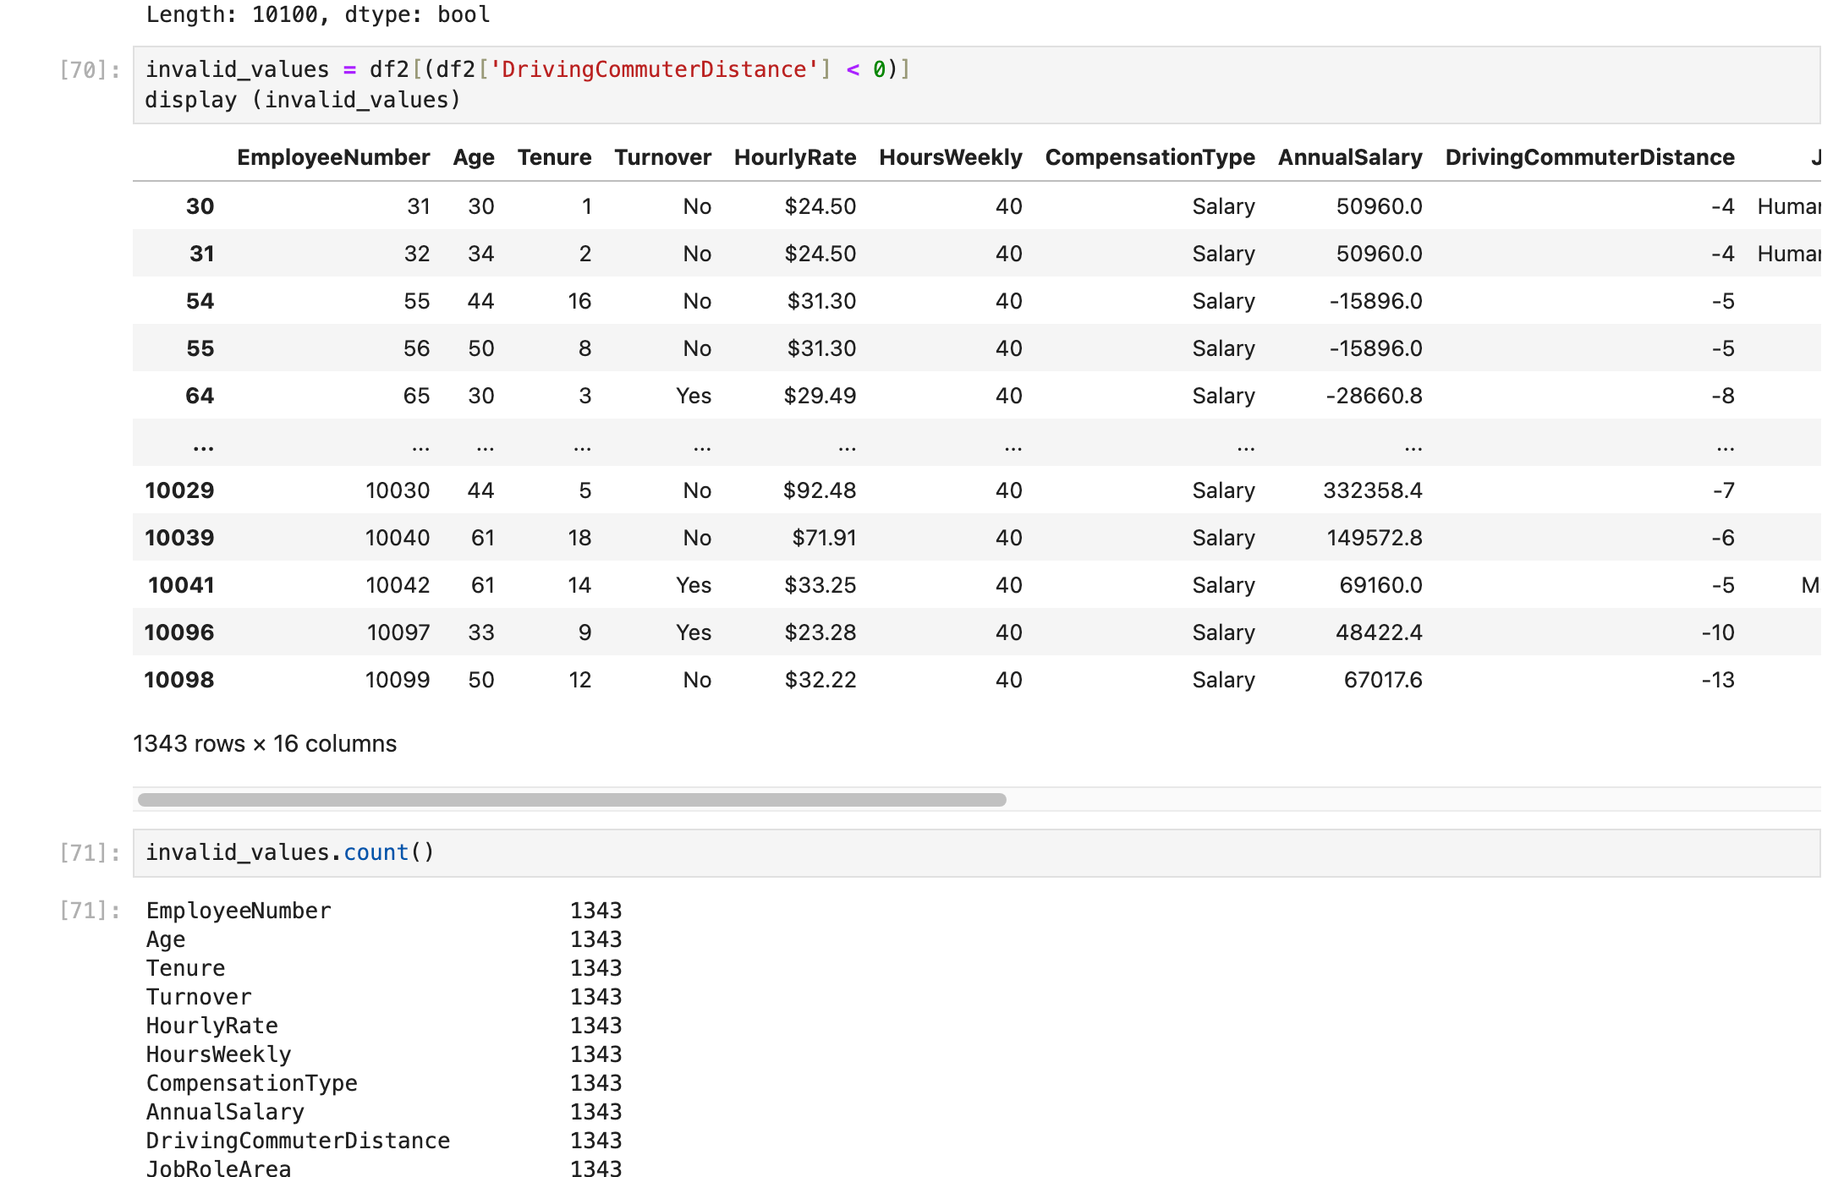
Findings:
- DrivingCommuterDistance and AnualSalary have negative values which should be positive.

C. Data Cleaning Techniques Used

1. How the Dataset Was Modified
Techinques | Resolve | Code Snippet
Duplicates | Removed using drop_duplicates() | 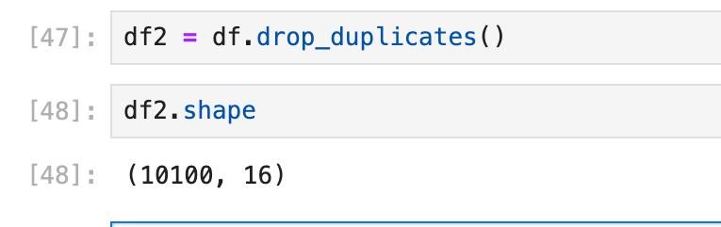
Missing Values | Dope missing values | 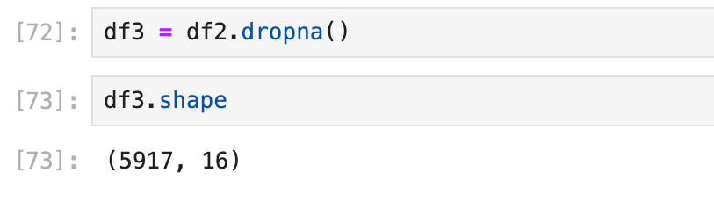
Outliers | Drop values with more than 40 hours. | 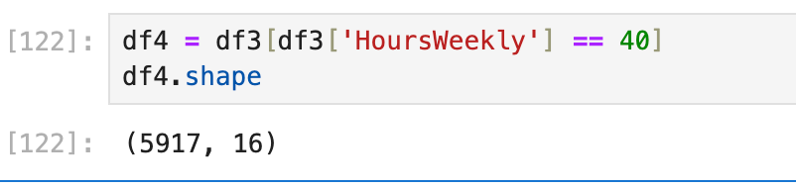
Formatting | Replace to Mail Check or Direct Deposit to clean up format for PaycheckMethod | 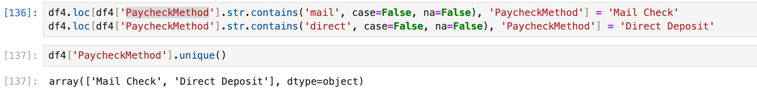
Accuracy | Convert AnnualSalary and DrivingCommuterDistannce to positive value | 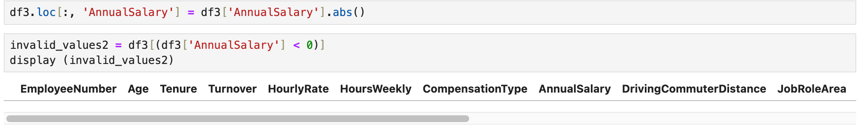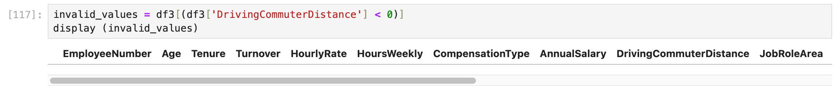

2. Why These Techniques Were Chosen
Duplicate rows can skew analysis by overrepresenting certain data points, resulting in biased insights. Missing values, particularly in numerical or statistical fields, can disrupt models and lead to incomplete conclusions, so handling them ensures data integrity. Work hours exceeding 40 may indicate invalid entries or outliers; if 40 is the defined maximum, removing these values maintains consistency. Inconsistent formatting in text fields like PaycheckMethod (e.g., "Mail", "mail", "Mail check") can hinder grouping and filtering — standardizing these entries improves data clarity and model readiness. Lastly, converting values that should never be negative, such as AnnualSalary or DrivingCommuterDistance, corrects data entry errors and enhances overall data accuracy for analysis.

3. Advantages of the Data Cleaning Approach
- Improves data quality and consistency without excessive data removal.
- Prepares data for reliable analysis and modeling.
- Ensures accurate grouping of categories

4. Limitations of the Approach
- Imputation may introduce bias, especially for small datasets.
- Outlier removal can discard legitimate rare cases.
- Cleaning based on rules (e.g., Age > 18) may miss contextual exceptions.

Reference:
- External resources not used in this submission

